DevOps Tutorial
- Version Management Tool (CI) : Git/GitHub, GitBucket, SVN, TFS
- DevOps Tools & Technologies: Agile, Scrum, Sprint, Backlog (Jira)
- DevOps Testing Tools: JDK, Python, Junit , Selenium
- CI-CD Tools : Jenkins, Bamboo
- Docker
- ServiceNow
- Provisioning Tools (Configuration Management Tool): Puppet , Ansible, Chef
- Infra : ELK Stack
- Monitoring Tools: Nagios, Sensu
- What is Splunk?
- NewRelic Alternatives
- VM, AWS, GoogleCloud, Azure

What is DevOps?
DevOps is a culture which promotes collaboration between Development and Operations Team to deploy code to production faster in an automated & repeatable way. The word 'DevOps' is a combination of two words 'development' and 'operations.'
DevOps helps to increases an organization's speed to deliver applications and services. It allows organizations to serve their customers better and compete more strongly in the market.
In simple words, DevOps can be defined as an alignment of development and IT operations with better communication and collaboration.
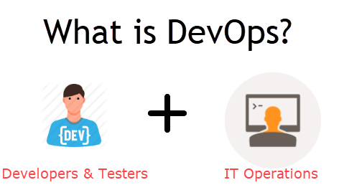

Why is DevOps is Needed?
- Before DevOps, the development and operation team worked in complete Isola tion.
- Testing and Deployment were isolated activities done after design-build. Hence they consumed more time than actual build cycles.
- Without using DevOps, team members are spending a large amount of their time in testing, deploying, and designing instead of building the project.
- Manual code deployment leads to human errors in production
- Coding & operation teams have their separate timelines and are not in synch causing further delays.
There is a demand to increase the rate of software delivery by business stakeholders. As per Forrester Consulting Study, Only 17% of teams can use delivery software fast enough. This proves the pain point.

How is DevOps different from traditional IT
Let's compare traditional software waterfall model with DevOps to understand the changes DevOps bring.
We assume the application is scheduled to go live in 2 weeks and coding is 80% done. We assume the application is a fresh launch and the process of buying servers to ship the code has just begun-
Old Process | DevOps
After placing an order for new servers, the Development team works on testing. The Operations team works on extensive paperwork as required in enterprises to deploy the infrastructure. | After placing an order for new servers Development and Operations team work together on the paperwork to set-up the new servers. This results in better visibility of infrastructure requirement.
Projection about failover, redundancy, data center locations, and storage requirements are skewed as no inputs are available from developers who have deep knowledge of the application. | Projection about failover, redundancy, disaster recovery, data center locations, and storage requirements are pretty accurate due to the inputs from the developers.
Operations team has no clue on the progress of the Development team. Operations team develop a monitoring plan as per their understanding. | In DevOps, the Operations team is completely aware of the progress the developers are making. Operations team interact with developers and jointly develop a monitoring plan that caters to the IT and business needs. They also use advance Application Performance Monitoring (APM) Tools
Before go-live, the load testing crashes the application. The release is delayed. | Before go-live, the load testing makes the application a bit slow. The development team quickly fixes the bottlenecks. The application is released on time.

Why is DevOps used?
DevOps allows Agile Development Teams to implement Continuous Integration and Continuous Delivery. This helps them to launch products faster into the market.
Other Important reasons are:
1. Predictability: DevOps offers significantly lower failure rate of new releases
2. Reproducibility: Version everything so that earlier version can be restored anytime.
3. Maintainability: Effortless process of recovery in the event of a new release crashing or disabling the current system.
4. Time to market: DevOps reduces the time to market up to 50% through streamlined software delivery. This is particularly the case for digital and mobile applications.
5. Greater Quality: DevOps helps the team to provide improved quality of application development as it incorporates infrastructure issues.
6. Reduced Risk: DevOps incorporates security aspects in the software delivery lifecycle. It helps in reduction of defects across the lifecycle.
7. Resiliency: The Operational state of the software system is more stable, secure, and changes are auditable.
8. Cost Efficiency: DevOps offers cost efficiency in the software development process which is always an aspiration of IT companies' management.
9. Breaks larger code base into small pieces: DevOps is based on the agile programming method. Therefore, it allows breaking larger code bases into smaller and manageable chunks.

When to adopt DevOps?
DevOps should be used for large distributed applications such as eCommerce sites or applications hosted on a cloud platform.

When not to adopt DevOps?
It should not be used in a mission-critical application like bank, power and other sensitive data sites. Such applications need strict access controls on the production environment, a detailed change management policy, access control policy to the data centers.

DevOps Lifecycle
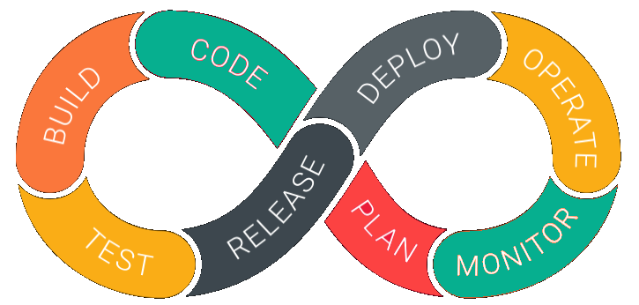
DevOps is deep integration between development and operations. Understanding DevOps is not possible without knowing DevOps lifecycle.
Here is a brief information about the Continuous DevOps life-cycle:
1. Development
In this DevOps stage the development of software takes place constantly. In this phase, the entire development process is separated into small development cycles. This benefits DevOps team to speed up software development and delivery process.
2. Testing
QA team use tools like Selenium to identify and fix bugs in the new piece of code.
3. Integration
In this stage, new functionality is integrated with the prevailing code, and testing takes place. Continuous development is only possible due to continuous integration and testing.
4. Deployment
In this phase, the deployment process takes place continuously. It is performed in such a manner that any changes made any time in the code, should not affect the functioning of high traffic website.
5. Monitoring
In this phase, operation team will take care of the inappropriate system behavior or bugs which are found in production.

DevOps Work Flow
Workflows provide a visual overview of the sequence in which input is provided. It also tells about actions are performed, and output is generated for an operations process.
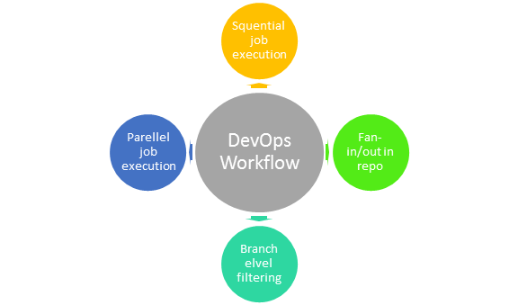
Workflow allows the ability to separate and arrange jobs which are top-requested by the users. It also gives the ability to mirror their ideal process in the configuration jobs.

How is DevOps different from Agile? DevOps Vs Agile
Stakeholders and communication chain a typical IT process.
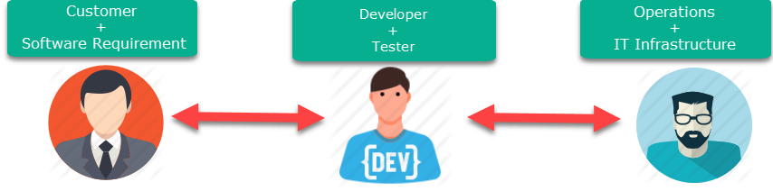
Agile addresses gaps in Customer and Developer communications
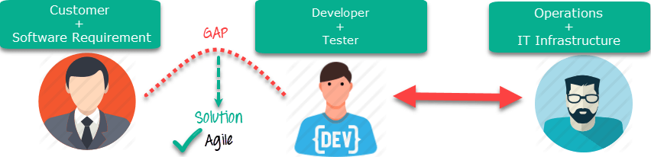
DevOps addresses gaps in Developer and IT Operations communications
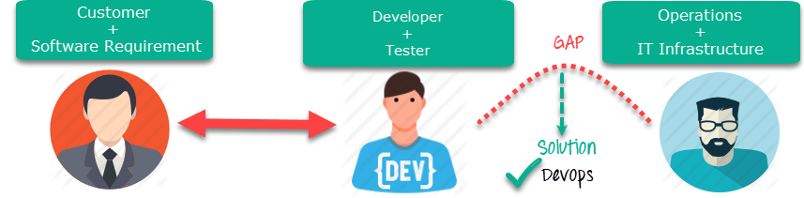
Agile | DevOps
Emphasize breaking down barriers between developers and management. | DevOps is about software deployment and operation teams.
Addresses gap between customer requirements and development teams. | Addresses the gap between development and Operation team
Focuses more on functional and non-functional readiness | It focuses operational and business readiness.
Agile development pertains mainly to the way development is thought out by the company. | DevOps emphases on deploying software in the most reliable and safest ways which aren't necessarily always the fastest.
Agile development puts a huge emphasis on training all team members to have varieties of similar and equal skills. So that, when something goes wrong, any team member can get assistance from any member in the absence of the team leader. | DevOps, likes to divide and conquer, spreading the skill set between the development and operation teams. It also maintains consistent communication.
Agile development manages on "sprints. It means that the time table is much shorter (less than a month) and several features are to be produced and released in that period. | DevOps strives for consolidated deadlines and benchmarks with major releases, rather than smaller and more frequent ones.

DevOps Principles
Here, are six principles which are essential when adopting DevOps:
1. Customer-Centric Action: DevOps team must take customer-centric action for that they should constantly invest in products and services.
2. End-To-End Responsibility: The DevOps team need to provide performance support until they become end-of-life. This enhances the level of responsibility and the quality of the products engineered.
3. Continuous Improvement: DevOps culture focuses on continuous improvement to minimize waste. It continuously speeds up the improvement of product or services offered.
4. Automate everything: Automation is a vital principle of DevOps process. This is not only for the software development but also for the entire infrastructure landscape.
5. Work as one team: In the DevOps culture role of the designer, developer, and tester are already defined. All they needed to do is work as one team with complete collaboration.
6. Monitor and test everything: It is very important for DevOps team to have a robust monitoring and testing procedures.

Who is a DevOps Engineer?
A DevOps Engineer is an IT professional who works with software developers, system operators, and other production IT staff to administer code releases. DevOps should have hard as well as soft skills to communicate and collaborate with development, testing, and operations teams.
DevOps approach needs frequent, incremental changes to code versions, which means frequent deployment and testing regimens. Although DevOps engineers need to code occasionally from scratch, it is important that they should have the basics of software development languages.
A DevOps engineer will work with development team staff to tackle the coding and scripting needed to connect elements of code, like libraries or software development kits.

Roles, Responsibilities, and Skills of a DevOps Engineer
DevOps engineers work full-time. They are responsible for the production and ongoing maintenance of a software application's platform.
Following are some expected Roles, Responsibilities, and Skills that is expected from DevOps engineer:
- Able to perform system troubleshooting and problem-solving across platform and application domains.
- Manage project effectively through open, standards-based platforms
- Increase project visibility thought traceability
- Improve quality and reduce development cost with collaboration
- Analyse, design and evaluate automation scripts & systems
- Ensuring critical resolution of system issues by using the best cloud security solutions services
- DevOps engineer should have the soft skill of problem-solver and quick-learner

How much does DevOps engineer make?
DevOps is one of the most trending IT profession. That is why there is plenty of opportunities out there. As a result, pay scale even for junior level DevOps engineer is quite high. Approximate salary of Junior DevOps engineer in India is 11, 15,801 per year. The average salary for junior DevOps Engineer is $78,696 per year in the United States of America.

DevOps Training Certification
DevOps training certification helps anyone who aspires to make a career as a DevOps Engineer. Certifications are available from Amazon web services, Red Hat, Microsoft Academy, DevOps Institute.
Let's consider them one by one
AWS Certified DevOps Engineer
This DevOps Engineering certificate tests you on how to use the most common DevOps patterns to develop, deploy, and maintain applications on AWS. It also evaluates you on the core principles of the DevOps methodology.
This certification has 2 requisites. The certification fee is $300 and duration is 170 minutes.
Red Hat Certification:
A Red Hat offers different level of certifications for DevOps professionals as follows -
- Red Hat Certificate of Expertise in Platform-as-a-Service
- Red Hat Certificate of Expertise in Containerized Application Development
- Red Hat Certificate of Expertise in Ansible Automation
- Red Hat Certificate of Expertise in Configuration Management
- Red Hat Certificate of Expertise in Container Administration
Devops Institute
The DevOps Institute is the global learning community around emerging DevOps practices. This organization is setting the quality standard for DevOps competency-based qualifications. The DevOps Institute currently offers three classes and certifications.
The certification course offered by the company are:
- DevOps Foundation
- DevOps Foundation Certified
- Certified Agile Service Manager
- Certified Agile Process Owner
- DevOps Test Engineering
- Continuous Delivery Architecture
- DevOps Leader
- DevSecOps Engineering

DevOps Automation Tools
It is vital to automate all the testing processes and configure them to achieve speed and agility. This process is known as DevOps automation.
The difficulty faced in large DevOps Team that maintain large huge IT infrastructure can be classified briefly into six different categories.
- Infrastructure Automation
- Configuration Management
- Deployment Automation
- Performance Management
- Log Management
- Monitoring.
Let's see a few tools in each of these categories and how they solve the pain points–
Infrastructure Automation
Amazon Web Services (AWS): Being cloud service you do not need to be physically present in the data center. Also, they are easy to scale on-demand. There are no up-front hardware costs. It can be configured to provision more servers based on traffic automatically.
Configuration Management
Chef: It is a useful DevOps tool for achieving speed, scale, and consistency. It can be used to ease out complex tasks and perform configuration management. With this tool, DevOps team can avoid making changes across ten thousand servers. Instead, they need to make changes in one place which is automatically reflected in other servers.
Deployment Automation
Jenkins: This tool facilitates continuous integration and testing. It helps to integrate project changes more easily by quickly finding issues as soon as a built is deployed.
Log Management
Splunk: This is a tool solves the issues like aggregating, storing, and analyzing all logs in one place.
Performance Management
App Dynamic: It is DevOps tool which offers real-time performance monitoring. The data collected by this tool helps developers to debug when issues occur.
Monitoring
Nagios: It is also important to make sure people are notified when infrastructure and related services go down. Nagios is one such tool for this purpose which helps DevOps teams to find and correct problems.

What is the future of DevOps?
They are lots of Change likely to happens in the DevOps world some most prominent are:
- Organizations are shifting in their needs to weeks and months instead of years.
- We will see soon that DevOps engineers have more access and control of the end user than any other person in the enterprise.
- DevOps is becoming a valued skill for IT people. For example, a survey conducted by Linux hiring found that 25% of respondent's job seeker is DevOps expertise.
- DevOps and continuous delivery are here to stay. Therefore companies need to change as they have no choice but to evolve. However, the mainstreaming the notion of DevOps will take 5 to 10 years.

Summary
- DevOps is a culture which promotes collaboration between Development and Operations Team to deploy code to production faster in an automated & repeatable way
- Before DevOps operation and Development team working in completed isolation.
- Manual code deployment leads to human errors in production
- In the Old process, Operations team has no clue on the progress of the Development team. So, operations team developed a IT infrastructure purchase and monitoring plan as per their understanding.
- In the DevOps process operation team fully aware of the progress of developer. The purchase and monitoring planning is accurate.
- DevOps offers Maintainability, Predictability, Greater quality cost efficiency and time to market.
- Agile process focuses on functional and non-functional readiness while DevOps focuses on that IT infrastructure aspects.
- DevOps life cycle includes Development, Testing, Integration, Deployment, and Monitoring.
- DevOps engineer will work with development team staff to tackle the coding and scripting needs.
- DevOps engineer should have the soft skill of a problem-solver and be a quick-learner
- DevOps Certifications are available from Amazon web services, Red Hat, Microsoft Academy, DevOps Institute
- DevOps helps organizations in shifting their code deployment cycles to weeks and months instead of years.

